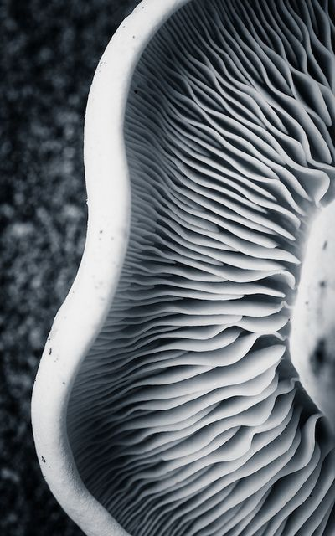
Aurora
Aurora is the glow in a planet’s ionosphere caused by the interaction between the planet’s magnetic field and charged particles from the sun.

The Aurora jacket features built-in VynEL lighting and Luna Gel glow fabric that senses low light, therefore automatically turning on when you walk outside at night to go for a jog or a bike ride.

I wanted to design an athletic jacket that would also work for leisure wear. A jacket that I can wear all day and then after class or a long day at work, be able to go for a night run and still be seen. It’s safe and stylish.
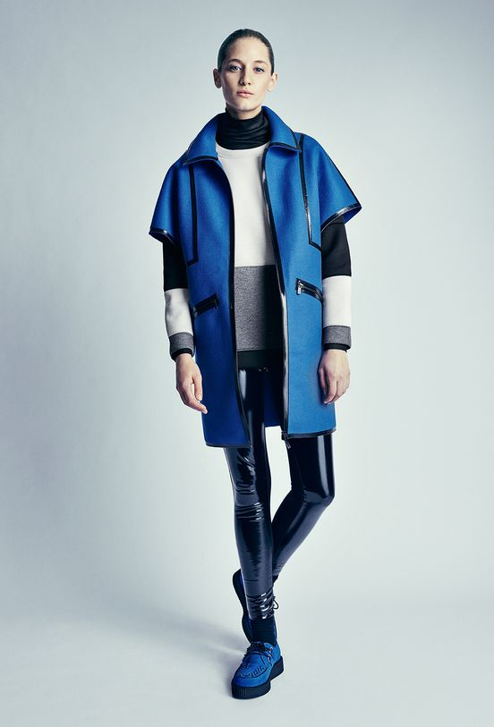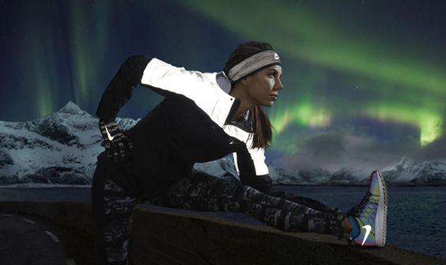
Aurora is unique because it’s made from textiles very new to the market. Neoprene is becoming more and more popular in everyday wear. It is lightweight, comfortable and water resistant. It also features modern and futuristic aesthetics which is what I aimed for with Aurora. VynEL lighting is flexible like fabric and very easily integrated into athletic wear. It generates no heat. Luna Gel glow fabric is environmentally friendly and machine washable. The fabric charges during the day by absorbing natural light and emits that light’s energy when exposed to low lighting or darkness.
Aurora can be worn as a casual jacket during the day and as an athletic jacket by night.
Laser cut neoprene allows for many different cut designs or customizable patterns and etching. Light placement is also adjustable with the simple design of the jacket.

